**Project Report**

Name: Sahibkamaljot singh (2061921)

**Introduction:** A C++ program that inputs the mathematical shapes and calculates it’s length,breadth,height and radius. This program automatically calculates the area of circle, Triangle,Square,Rectangle.

**Project implementation:** firstly, I made a rough design of this program and made a UCASE DIAGRAM Which make me easy to convert into the C++ code. I had to use ‘if else

statement’, arithmetic operator and logical operator in the program and other basic C++ syntax.

**Implementation:**

In this program firstly we displays the message of hello guys and ask for the input of length breadth and radius of circle. Then after i have used class named shape with a function called input. ’input’ function takes input of length, breadth n radius of the geometrical shapes. After that 4subclasses has been used named as rectangle triangle circle and square. Those inherited classes are defined with the a function called area where there is formula of each shape.

**Project output:**

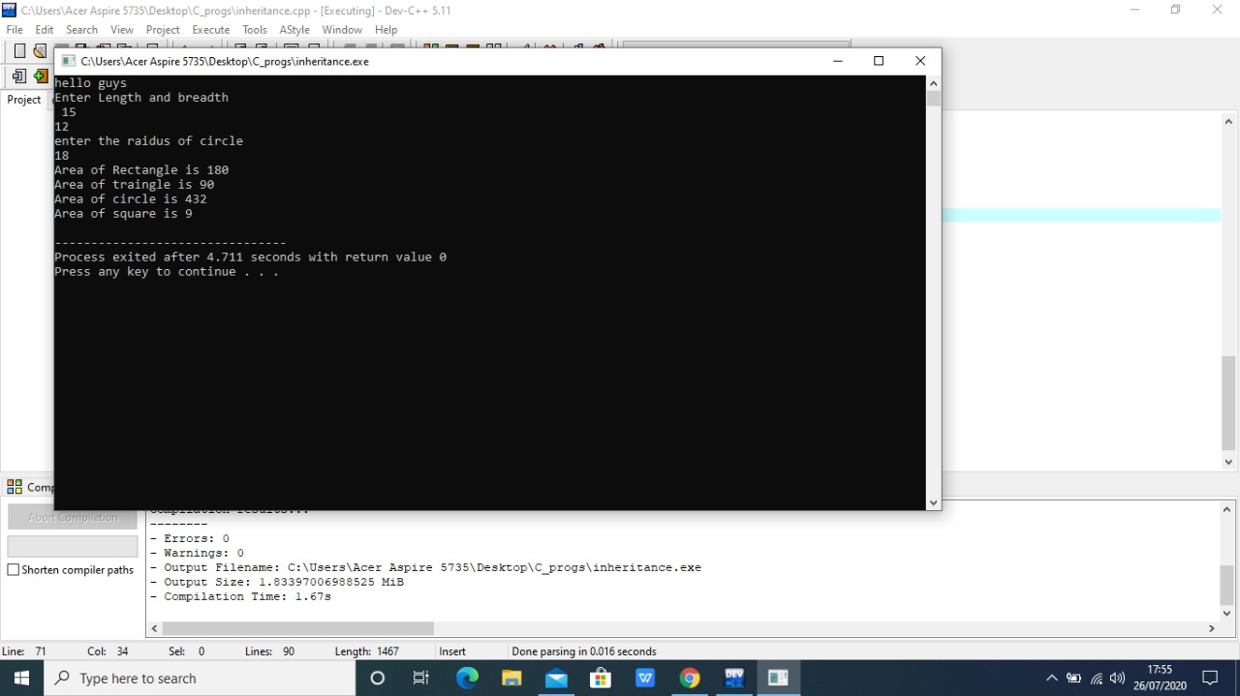

Output 1:

**Conclusion:** In conclusion the project works effectively and efficiently and also got the desired result. This can be used as a calculator in future. It also can be upgraded and more features can be added.